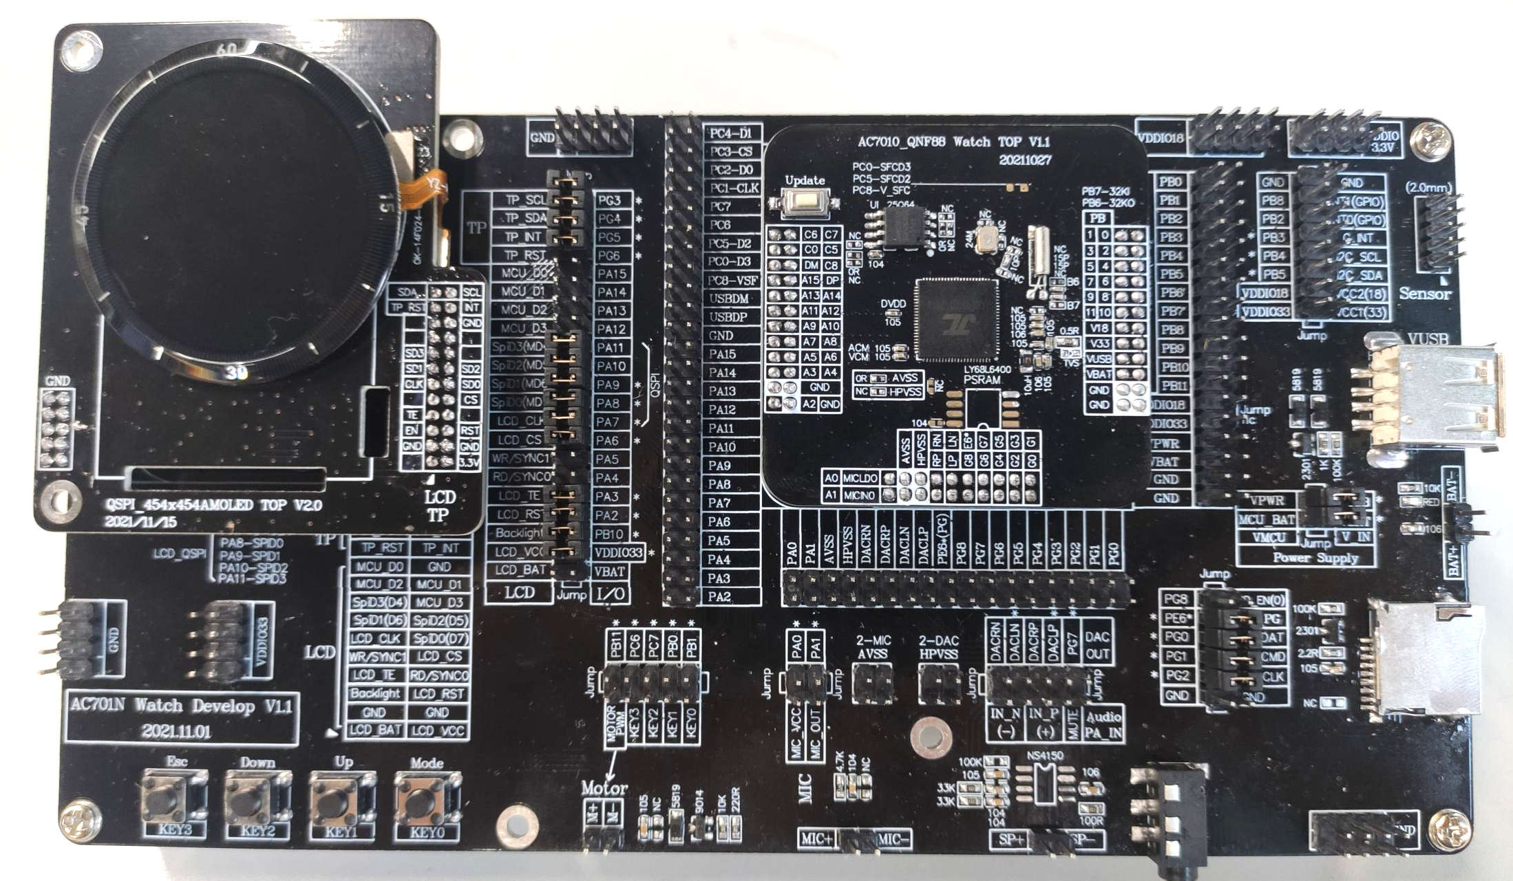

|  |  |  |  |  |  |
| --- | --- | --- | --- | --- | --- |
| 外设类型 | 接口 | | | 跳冒默认网络  （NC）表示不需要跳冒 | “*”表示默认相同 “NC”表示不要跳冒 |
| 全封装QFN88 | JL7012A_QFN52 |
| LCD  (默认Dspi屏) | LCDBAT（预留电源） | |  | VBAT(NC) | * |
| LCDVCC主电源 |  |  | VDDIO33 | * |
| Backlight背光pwm |  |  | PB10（支持低功耗背光） | PB9（支持低功耗背光） |
| LCD_RST复位 |  |  | PA2 | * |
| LCD_TE帧同步 |  |  | PA3 | * |
|  | RGB_SYNC0 | MCU_RD | PA4（NC） | NC |
|  | RGB_SYNC1 | MCU_WR | PA5（NC） | NC |
| LCD_SPI_CS |  |  | PA6 | * |
| LCD_SPI_CLK | RGB_CLK |  | PA7 | * |
| LCD_SPI_SD0 | RGB_D7 | MCU_D7 | PA8 | * |
| LCD_SPI_SD1 | RGB_D6 | MCU_D6 | PA9 | * |
| LCD_SPI_SD2 | RGB_D5 | MCU_D5 | PA10 | * |
| LCD_SPI_SD3 | RGB_D4 | MCU_D4 | PA11 | * |
|  | RGB_D3 | MCU_D3 | PA12（NC） | NC |
|  | RGB_D2 | MCU_D2 | PA13（NC） | NC |
|  | RGB_D1 | MCU_D1 | PA14（NC） | NC |
|  | RGB_D0 | MCU_D0 | PA15（NC） | NC |
| TP | TP_RST |  |  | PG6 | PA2与LCD_RST共用 |
| TP_INT |  |  | PG5 | * |
| TP_SDA |  |  | PG4 | * |
| TP_SCL |  |  | PG3 | * |
|  | | | | | |
| Sensor | VCC1主电源 |  |  | VDDIO33 | 邦一起，跟随VDDIO33 |
| VCC2（预留） |  |  | VDDIO18 |
| I2C_SDA |  |  | PB5 | * |
| I2C_SCL |  |  | PB4 | * |
| G_INT |  |  | PB3 | * |
| INT0 |  |  | PB2（NC） | PG6 |
| INT1 |  |  | PB8（NC） | PG8 |
|  | | | | | |
| SD Nand | VCC_EN | 外置电源mos，0使能 | | PG8（NC） | * |
| SD_PG，默认 | SDnand电源接口 | | PE6 | * |
| SD_DAT |  |  | PG0 | * |
| SD_CMD |  |  | PG1 | * |
| SD_CLK |  |  | PG2 | * |
|  | | | | | |
| 震动马达 | Motor pwm |  |  | PB11 | PA5 |
| Motor VCC | 固定连接 |  | VBAT | * |
| key | KEY0 |  |  | PB1 | * |
|  | KEY1 |  |  | PB0 | USBDM |
|  | KEY2 |  |  | PC7 | USBDP |
|  | KEY3 |  |  | PC6 | * |
|  | | | | | |
| 驻极体麦 | MIC_VCC |  |  | PA0（micldo） | * |
| MIC_OUT |  |  | PA1（micin） | * |
| MIC_GND | 固定连接 |  | AVSS | * |
|  | | | | | |
| 音频功放 | IN_P |  |  | DACLP | DACLP |
|  |  | DACRP(NC) | NC |
| IN_N |  |  | DACLN | DACRP |
|  |  | DACRN(NC) | NC |
| MUTE |  |  | PG7 | * |
| PA_VCC | 固定链接 |  | VBAT | * |
| PA_GND | 固定链接 |  | HPVSS（DAC地） | * |
| SP+ | 喇叭+ | 耳机+ |  | * |
| SP- | 喇叭- | 耳机- |  | * |
|  | | | | | |
| USB | 充电VUSB | DM,DP升级 |  | DM,DP | * |

|  |  |
| --- | --- |
| 开发板电源 | 主控网络 |
| VBAT+ | VBAT |
| VUSB | VPWR |
| VDDIO33 | IOVDD |
| VDDIO18 | IOVDD2 |

|  |  |  |  |
| --- | --- | --- | --- |
|  | 最小系统顶板网络 | 功能说明 | 备注 |
| VPWR | 5V充电输入 | 单向TVS管保护，旁路电容 |
| VBAT | 锂电池电池 | 旁路电容 |
| QFN52邦定一起跟随IOVDD(3.3V) | IOVDD | IO口电源（除PB） | 10uf旁路电容 |
| IOVDD2 | PB口电源 | 旁路电容 |
|  | SW | DC-DC开关信号 | 功率电感 |
| DCVDD | 内部供电 | 旁路电容 |
| DVDD | 内部供电 | 旁路电容 |
| BTRF | 蓝牙天线 | 预留π网络 |
| XOSCI | 24Mhz | 晶振 |
| XOSCO |
| PB6（可免晶振做I/O） | 32.768K | 晶振+负载电容 |
| PB7（可免晶振做I/O） |
| VSS | 数字/射频地 | 接地 |
| QFN52邦定一起  （统称AVSS） | AVSS | 音频参考地 | 接地 |
| HPVSS | 驱动级功率地 | 接地 |
|  | PC8（强驱供电） | SPIVCC | 外挂 NOR flash（UI） QSPI接口 |
| PC0 | SPID3 |
| PC1 | SPICLK |
| PC2 | SPID0 |
| PC3（上电同步上拉） | SPICS |
| PC4 | SPID1 |
| PC5 | SPID2 |

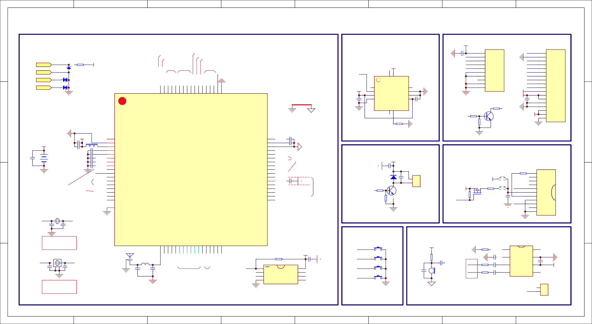

1

2

3

4

5

6

7

8

9

10

Q3 2301

***GSensor***

LEDK

105 CTP_SCL

V_SFC

C17

104

8

VBAT VDDIO33

C24

LCD_TE SD0 SD1 SD2 SD3

LCD_CLK LCD_CS LCD_RST VBAT

105

R3

LEDK

1

2

3

4

1

2

3

4

22R

VDDIO33

1

2

3

4

5

5

5

6

7

8

9

10

11

12

13

14

15

0

R6 10K

SD nand供电必须可控，减少待机电流

1.无内封psram方案，使用PE6口的SDPG功能供电 2.内封psram方案，外加mos做电源开关

R16 NC

VDDIO33

R9 100K

SD_EN

SD_PG

R14 2.2R

SD_CMD

10

9

8

7

D3 ESD

D4 ESD

***Audio***

C19 104

G_INT GSensor

R7 NC

VDDIO33

C18 104

J1

VDD2.8 SCL SDA EINT RESET GND GND NC GND GND

CTP-1.54INCH

触摸屏

USBDM

7

6

5

DP

USB升级

USBDP

VDDIO33

C23

U1

CS SO/IO1 WP/IO2 GND

外置UI flash

音频地layout时必须连接到电池地回路

Backlight_PWM

NC 1

2

MOT

震动马达

GND

VBAT

SFC_CS

SFC_D1 SFC_D2

USB升级

外置UI flash

DACLN

差分音频

M1

104

R11

33K

C21

104

3

IN+

VDD

6

VBAT

MIC

+

4

5 SPK-

R12 33K

IN-

OUT-

C22 104

麦克风的地单独布线连接至芯片AVSS

尽量与MIC布线贴近，减少环路面积

MIC信号布线远离数字和射频干扰，尽量做好包地保护

NS4150 外置功放

SPK+ SPK-

J4

1

2

SPK

105

C29 105

SD_DAT

10

9

1

2

3

4

5

6

7

8

11

TF1

CD WP D2 D3/CS CMD VDD CLK VSS D0

D1

Sheet

SD-TF

MICLDO

R13

100K MUTE 1

U4

MUTE OUT+

8 SPK+

R8 2.2K

SD_CLK

C30

2

7

C20

Bypass GND

MIC

DACLP

GND

C31 106

C28 NC

VPWR

VBAT

C6 105

KEY4/UartTX1

DCVDDL1

10uH

VDD

VPWR充电输入接口，直流输入≤5.5V，

VPWR供电时，同时也给电池和系统供电

R1

背光PWM

震动马达

+5.0V

D1

单向TVS保护

0.5R(0603)

C1 105

C9 106

***KEY***

L2 10P

C13 NC

KEY2

* S4

KEY3

*

* S2

* S3

KEY0

KEY1

S1

R5 10K

PWM口可映射到任意I/O Motor_PWM R4

1K

C27

BT1

3.3V~4.2V

***MCU***

***LCD/TP***

DCVDD 8

Sensor_int1 9

Sensor I2C

43 WR/SYNC1

42 LCD_CS

41 LCD_CLK

40 DVDD

39 SD0(D7)

若使用低压sensor，电源可换成IOVDD2

若预防se nsor跑死，电源可使用一个普通I/O口供电

VPWR 5

VDDIO33 6

VDDIO18 7

AVSS

C2 105

C3 105 C10106 C4 105

C5 105

D2 5819

C25 106

Y1 24M

BT_OSCO BT_OSCI

C11 C12

NC NC

2

3

4

IIC_SDA

C14 NC

***Motor***

BT_ANT1

音频功放使能

SDnand供电mos控制

SDnand专用供电口(内封psram时，此口为psram电源)

音频输出

SD nand 触摸屏 优先用DACLP/N（差分）

Q1 9014

32KI

C16 15P

24Mhz晶振要求： 频率误差：±10ppm负载电容要求：12PF

J2

LEDK GND FMARK SD0 SD1 SD2 SD3 SCL

CS RESET VBAT IOVCC VCC2.8 GND GND LEDA LEDA

shell

QSPI_AMOLED

SP I显示屏

0

***SD***

VSS(PAD)

**开发板*I/O*分配参照**

38 SD1(D6) QSPI

37 SD2(D5)

36 SD3(D4)

LCD_D3/PA12 35 D3

32KO

C15 15P

Y2 32.768K

RST，TE，CS可更换到其他I/O

R2

NC/10K

Q2 9014

32KI 10

32KO 11

IIC_SDA 12

IIC_SCL 13

G_INT 14

Sensor_int0 15

KEY0 16

KEY1 17

SFC_D3 SFC_CLK

SFC_D0

DM

IO3/HOLD

SCK IO0/SI

25Q128

spi时钟频率：96Mhz/120Mhz

跑DSPI模式时，PC5和PC0可释放做普通IO

GND

GND

R10

510R

U2

VCC

U3

J3

C26

105

VBAT

NC

VDD_IO GND_IO

CSB GND

SD0 SDA/SDI/SDO

CTP_SDA

CTP_INT CTP_RST

PB9/SPI4CLKB/I2C1SCLB/ADC9 PGND

SW VBAT VPWR IOVDD IOVDD2 DCVDD PB8

PB7/ROSCI PB6/ROSCO PB5/I2C1SDAA/ADC8 PB4/SPI4DIA/I2C1SCLA PB3/SPI4DOA PB2/SPI4CLKA/ADC7

PB1/ADC6/Long press reset

C7 105

PB0

VDDIO33

L

IIC_SC

Sensor int0/1预留I/O

预留I/O给血氧和其他传感器

音频模拟地

AVSS

51 VCM

50 ACM

49 AVSS

48 MICLDO

47 MIC

46 LCD_RST

45 LCD_TE

44 RD/SYNC0

VCM ACM AVSS

ADC0/MICLDO/PA0 SPI1DIA/AIN_A0/PA1 SPI1CLKA/AIN_A1/PA2 SPIDOA/AIN_B0/PA3 WR/RD/RGB_SYNC0/SPI2DIA/AIN_B1/PA4 ADC1/WR/RD/RGB_SYNC1/SPI2CLKA/PA5 ADC2/WR/RD/RGB_SYNC2/SPI2DOA/PA6 LCD_SPICLKA(RGB_CLK)/PA7

DVDD ADC3/LCD_SPID0A(D7)/PA8 LCD_SPID1A(D6)/PA9 LCD_SPID2A(D5)/PA10 LCD_SPID3A(D4)/PA11

C8

105

**开发底板网络参考（非完整原理图）**

D D

Backlight_PWM Motor_PWM SD_DAT SD_CMD SD_CLK CTP_SCL CTP_SDA CTP_INT CTP_RST MUTE SD_EN SD_PG DACLP DACLN DACRP DACRN

12

11

SCL NC

C C

68

67

66

65

64

63

62

61

60

59

58

57

56

55

54

53

52

I2C1SDAB/SPI4DOB/PB10

SPI4DIB/PB11 ADC12/SD0DATB/PG0 ADC13/SD0CMDB/PG1

SD0CLKB/PG2 LCD_SPICLKB/PG3 LCD_SPID0B/PG4 ADC14/LCD_SPID1B/AIN_D1/PG5 LCD_SPID2B/AIN_D0/PG6 ADC15/LCD_SPID3B/AIN_C1/PG7

AIN_C0/PG8 SDPG/PE6 DACLP DACLN DACRP DACRN HPVSS

5

6

INT INT2

B B

BTRF XOSCI XOSCO PC7 PC6

PC5/SFC1_D2/ADC5 PC4/SFC1_D1/ADC4 PC3/SFC1_CS PC2/SFC1_D0 PC1/SFC1_CLK PC0/SFC1_D3

PC8 USBDM/ADC11 USBDP/ADC10 PA15/LCD_D0 PA14/LCD_D1 PA13/LCD_D2

32.768Khz晶振要求：频率误差：±20ppm ESR≤70KΩ

A A

18

BTRF

19

BT_OSCI

BT_OSCO 20

21

22

23

24

25

26

27

28

29

30

31

32

33

34

KEY2 KEY3 SFC_D2 SFC_D1 SFC_CS SFC_D0 SFC_CLK SFC_D3 V_SFC USBDM USBDP D0 D1 D2

# 开发底板原理图

#### J1 J2

5

|  |  |
| --- | --- |
| GND | 1  2  3  4  5  6  7  8  9  10  11  12  13  14  15  16  17  18  19  20  21  22  23  24 |
| GND |
| GND |
| GND |
| MCU_BAT |
| MCU_BAT |
| VPWR |
| VPWR |
| VDDIO33 |
| VDDIO33 |
| VDDIO18 |
| VDDIO18 |
| PB11 |
| PB10 |
| PB9 |
| PB8 |
| PB7 |
| PB6 |
| PB5 |
| PB4 |
| PB3 |
| PB2 |
| PB1 |
| PB0 |
|  |

PA2 1

GND 2

GND 3

GND 4

PA3

D PA4 6

PA5 7

PA6 8

PA7 9

PA8 10

J3

PG0 1

PG1 2

PG2 3

PG3 4

PG4 5

PG5 6

PG6 7

PG7 8

PG8 9

PE6 10

## LCD_BAT LCD_VCC

#### J4

Backlight_PWM LCD_RST LCD_TE RD/SYNC0 WR/SYNC1

|  |  |
| --- | --- |
| 2 | 1 |
| 4 | 3 |
| 6 | 5 |
| 8 | 7 |
| 10 | 9 |
| 12 | 11 |
| 14 | 13 |
| 16 | 15 |
| 18 | 17 |
| 20 | 19 |
| 22 | 21 |
| 24 | 23 |
| 26 | 25 |
| 28 | 27 |
| 30 | 29 |
| 32 | 31 |
| 34 | 33 |
| 36 | 35 |
| 38 | 37 |
| 40 | 39 |
| 42 | 41 |

LCD_CS

PB10 PA2 PA3 PA4 PA5

PA6

## PVCC VDDIO33

## LCD_BAT LCD_VCC

#### J6

Backlight_PWM LCD_RST LCD_TE RD/SYNC0

1

2

3

4

5

6

7

8

9

10

11

12

13

14

15

16

17

18

19

20

21

22

23

24

WR/SYNC1

## VMIC

#### R4

VMIC MIC_OUT

J8

### 1 2

3 4

#### DCON4

## D

PA0 PA1

PA9 11

PA10 12

PA11

DACLP 11

DACLN 12

DACRP

LCD_CLK SD0(D7)

PA7 PA8

LCD_CS LCD_CLK SD0(D7)

#### 4.7KC2

+ 104

MIC_OUT

# 麦克风跳线

### 13

PA12 14

PA13 15

PA14 16

PA15 17

USBDP

13

DACRN 14

HPVSS 15

HPVSS 16

AVSS 17

AVSS

SD1(D6)

SD2(D5) SD3(D4) D3

D2

PA9

PA10 PA11 PA12 PA13

J22

SD1(D6) SD2(D5) SD3(D4) D3

D2

1

2

3

4

5

6

7

8

9

10

#### C1 M1

NC MIC

隔直电容靠主控芯片摆放

J7

AVSS

1

2

3

4

### 18

USBDM 19

PC8 20

PC0 21

PC5 22

PC6

PA1 PA0

18

### 19

20

#### CON20

D1 D0

CTP_RST CTP_INT CTP_SDA

PA14 PA15 PG6 PG5 PG4

D1 D0

CTP_RST CTP_INT

麦的地单独布线连接至芯片AVSS

尽量与MIC 布线贴近，减少环路面积

#### AVSS

CON24

23

PC7 24

PC1 25

PC2 26

PC3 27

PC4

# 最小系统接口

CTP_SCL

#### DCON42

PG3

GND

CTP_SDA CTP_SCL

#### Port2.0mm

#### R3 100K

#### MUTE

U1

## 1 MUTE OUT+ 8

SPK+

## C

#### J10

28

#### J12

CON28

J11

LCM跳线 LCM模块接口

#### J19

|  |  |  |
| --- | --- | --- |
|  | | 1  2  3  4  5  6  7  8  9  10 |
|  | |
|  | IIC_SDA |
| IIC_SCL |
| G_INT |
| GND |
| Sensor_int0 |
| Sensor_int1 |
| GND |
| GND |
|  | |

PA_IN+

R1

33K

C5 10 5

C3 104

2 Bypass

## 3 IN+

### 4

## GND 7

VDD 6

### 5

GND

#### C6 106

C

## PVCC

J5

|  |  |  |
| --- | --- | --- |
|  | | 1  2  3  4  5  6  7  8  9  10  11  12  13  14  15  16  17  18 |
|  |  |
|  | MCU_BAT |
| VPWR |
| VDDIO33 |
| VDDIO18 |
| PB11 |
| PB10 |
| PB9 |
| PB8 |
| PB7 |
| PB6 |
| PB5 |
| PB4 |
| PB3 |
| PB2 |
| PB1 |
| PB0 |
|  | |

|  |  |
| --- | --- |
| PA2 | 1  2  3  4  5  6  7  8  9  10  11  12  13  14  15  16  17  18  19  20  21  22  23  24  25  26 |
| PA3 |
| PA4 |
| PA5 |
| PA6 |
| PA7 |
| PA8 |
| PA9 |
| PA10 |
| PA11 |
| PA12 |
| PA13 |
| PA14 |
| PA15 |
| GND |
| USBDP |
| USBDM |
| PC8 |
| PC0 |
| PC5 |
| PC6 |
| PC7 |
| PC1 |
| PC2 |
| PC3 |
| PC4 |
|  |

|  |  |
| --- | --- |
| PG0 | 1  2  3  4  5  6  7  8  9  10  11  12  13  14  15  16  17  18 |
| PG1 |
| PG2 |
| PG3 |
| PG4 |
| PG5 |
| PG6 |
| PG7 |
| PG8 |
| PE6 |
| DACLP |
| DACLN |
| DACRP |
| DACRN |
| HPVSS |
| AVSS |
| PA1 |
| PA0 |
|  |

|  |  |  |  |  |  |
| --- | --- | --- | --- | --- | --- |
|  | | 2  4  6  8  10  12  14  16 | 1  3  5  7  9  11  13  15 |  | |
|  | |  | |
|  | PB5 |  | IIC_SDA |
| PB4 |  | IIC_SCL |
| PB3 |  | G_INT |
| PB2 |  | Sensor_int0 |
| PB8 |  | Sensor_int1 |
| GND |  | GND |
|  | |  | |

## VDDIO33 VDDIO18

## VCC1 VCC2

VCC1 VCC2

PA_IN-

差分功放输入

#### R2 33K

#### C4 104

IN-

NS4150

## OUT-

外置功放

SPK-

#### DCON16

Sensor 跳线

#### J20

预留

预留

#### Earphone Jack

2 R12

4 100R

3 SPK-

1

SPK+

J24

|  |  |
| --- | --- |
| SPK+ | 1  2 |
| SPK- |
|  |

#### SPK

CON8

开发板耳机口，方便调试使用

CON18

## B

#### CON18

port口排针

#### J13

SD_EN SD_PG SD_DAT SD_CMD SD_CLK

|  |  |  |  |
| --- | --- | --- | --- |
| PG8 | 1 | 2 |  |
| PE6 |  |
| 3 | 4 |
| PG0 |  |
| 5 | 6 |
| PG1 |  |
| 7 | 8 |
| PG2 |  |
| 9 | 10 |
| GND |  |
| 11 | 12 |
|  |  |

GND

## VDDIO33

#### R8

#### R9 2.2R

## SD_PG

#### R11 NC

SD_CMD SD_CLK

TF1

10 CD

9 WP

1. D2
2. D3/CS
3. CMD
4. VDD
5. CLK

### 6

#### J15

#### J23

|  |  |  |  |  |
| --- | --- | --- | --- | --- |
| PG7 | 1 | 2 | MUTE | |
| DACLP |  | PA_IN+ |
| 3 | 4 |
| DACRP |  |  |
| 5 | 6 |
| DACLN | PA_IN- | |
| 7 | 8 |
| DACRN |  |  |
| 9 | 10 |
|  |  | |

## B

1

2

3

4

HPVSS

#### J9 J16

1

2

3

4

## VDDIO33

1

2

3

4

#### J17

1

2

3

4

## VDDIO18

#### CON26

J18

1

2

3

4

J21

VDDIO33 J26

#### DCON12

1

2

3

4

SD nand跳线

#### 100K

SD_EN

#### Q2 2301

C8

#### 105

SD_DAT

VSS

## D0

1. D1

DCON10

# 音频功放输入跳线

#### HPVSS

#### GND

#### GND

#### 3V3

6

6

#### 1V8

#### GND

1

2

3

4

GND

SD nand供电必须可控，减少待机电流 1.使用PE6口的SDPG功能供电

2.外加mos做电源开关

11 Sheet

#### SD-TF

MIC/PA

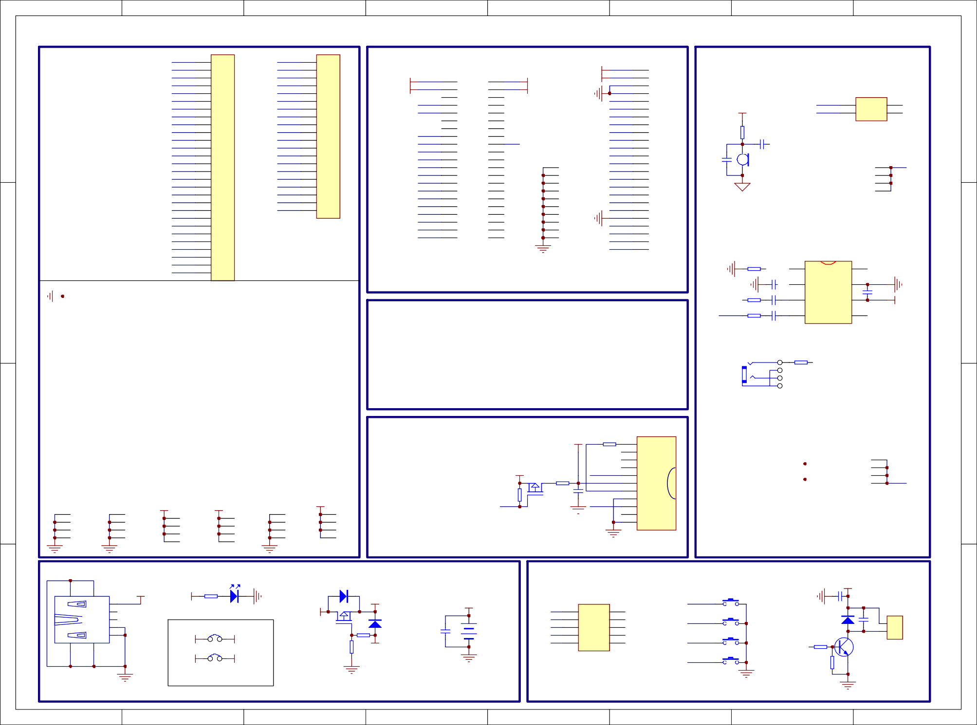

VPWR

* R14

10K

VUSB

JP1

PVCC

J14

1

3

5

7

9

S1

KEY0

C9

105

PB1 PB0 PC7 PC6

PB11

2

4

6

8

10

KEY0 KEY1 KEY2 KEY3

Motor_PWM

*

S

2

J25

KEY1

* S3

KEY2

DCON10

* S4

D4 5819

PWM口可映射到任意I/O Motor_PWM R13

220R

C10

NC 1

2

MOT

震动马达

KEY3

Q3 9014

PVCC

POWER

功放电源切换(方便开发板供电)

PC、升级

VUSB

R6 100K

BT1

3.3V~4.2V

C7 106

D3 5819

R7

1K

Q1 2301

VBAT

VBAT

VBAT

5819

实际应用VBAT和PVCC短接

D2

充电输入指示灯

D1

R5

10K

RED

1. USBDM
2. USBDP

4

5

VUSB

1

+5V DM DP ID GND

VUSB

USB1 USBA

JP2

主控电源跳冒(电流测试)

MCU_BAT

A A

6

6

